EXP-8 CODE:
clc; clear; close all;

Fs = 1000;
N = 20;
L = 128;

% FIR filter coefficients
h = fir1(N,0.3,hamming(N+1));

% Unit impulse input x = [1 zeros(1,L-1)];

% Direct realization y_direct = filter(h,1,x);

% Cascade realization using second-order sections [sos,g] = tf2sos(h,1);
y_cascade = g*x;

for k = 1:size(sos,1)
y_cascade = filter(sos(k,1:3),sos(k,4:6),y_cascade); end

% Check coefficient symmetry symmetry_error = max(abs(h-fliplr(h)));

% Frequency and phase response [H,f] = freqz(h,1,1024,Fs);

% Plot impulse responses figure;
stem(0:L-1,y_direct,'b'); hold on;
stem(0:L-1,y_cascade,'r--'); grid on;
xlabel('Samples'); ylabel('Amplitude');
title('Direct vs Cascade FIR Realization'); legend('Direct','Cascade');

% Phase response figure; plot(f,unwrap(angle(H))); grid on; xlabel('Frequency (Hz)'); ylabel('Phase (Radians)');
title('Linear Phase Response');

% Display results disp('FIR Coefficients:');

disp(h);

disp('Cascade SOS Coefficients:'); disp(sos);

fprintf('Symmetry Error = %g\n',symmetry_error); fprintf('Maximum Output Difference = %g\n', ...
max(abs(y_direct-y_cascade)));
fprintf('Linear Phase Group Delay = %.1f samples\n',N/2); fprintf('Group Delay = %.4f seconds\n',(N/2)/Fs);

OUTPUT:
FIR Coefficients: Columns 1 through 12

0 0.0029 0.0063 0.0038 -0.0124 -0.0343
-0.0319 0.0265 0.1379 0.2513 0.2996 0.2513

Columns 13 through 21

0.1379 | 0.0265 | -0.0319 | -0.0343 | -0.0124 | 0.0038
0.0063 | 0.0029 | 0

Cascade SOS Coefficients:
0 1.0000 0 1.0000 0 0

1.0000 | -3.4877 | 3.3363 | 1.0000 | 0 | 0
1.0000 | 0.4529 | 1.2411 | 1.0000 | 0 | 0

1.0000 | 1.4121 | 1.0000 | 1.0000 | 0 | 0
1.0000 | 0.8801 | 1.0000 | 1.0000 | 0 | 0
1.0000 | 1.9754 | 1.0000 | 1.0000 | 0 | 0
1.0000 | 1.7823 | 1.0000 | 1.0000 | 0 | 0
1.0000 | -0.1692 | 1.0000 | 1.0000 | 0 | 0
1.0000 | 0.3649 | 0.8057 | 1.0000 | 0 | 0
1.0000 | -1.0454 | 0.2997 | 1.0000 | 0 | 0

Symmetry Error = 0
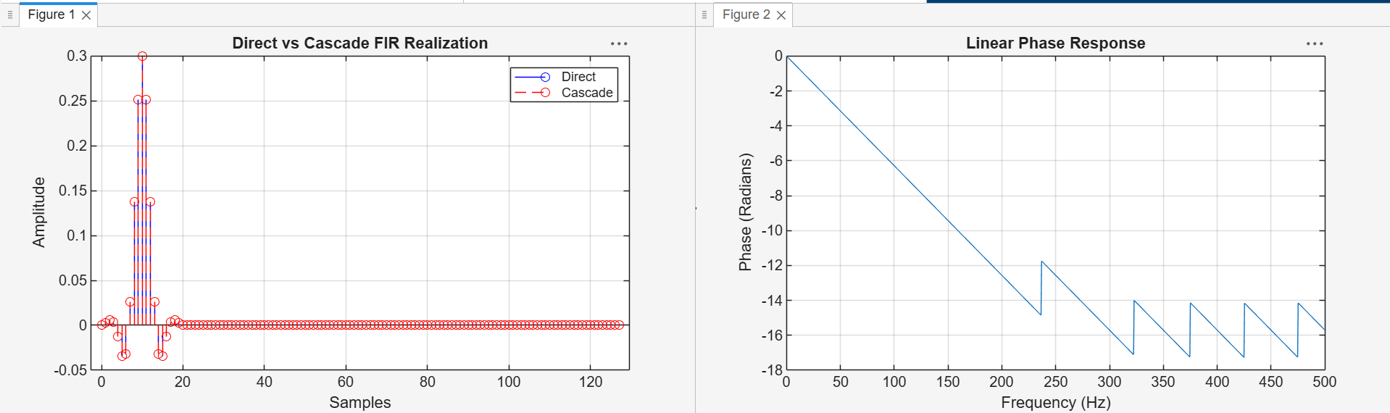
Maximum Output Difference = 3.10862e-15 Linear Phase Group Delay = 10.0 samples Group Delay = 0.0100 seconds

